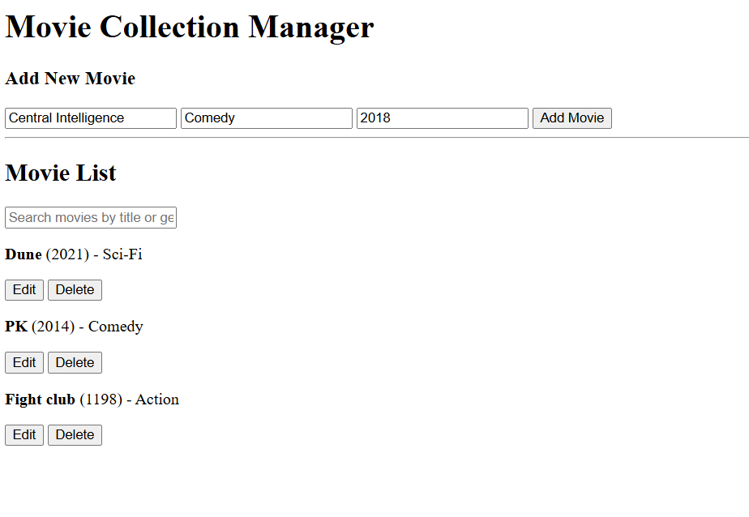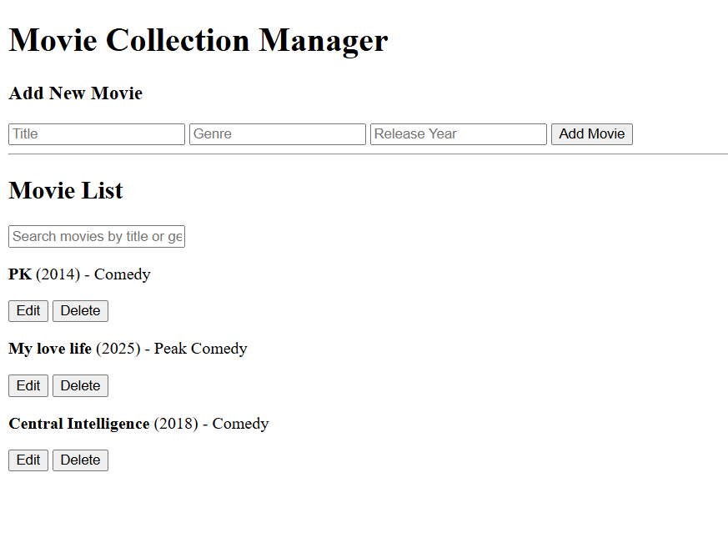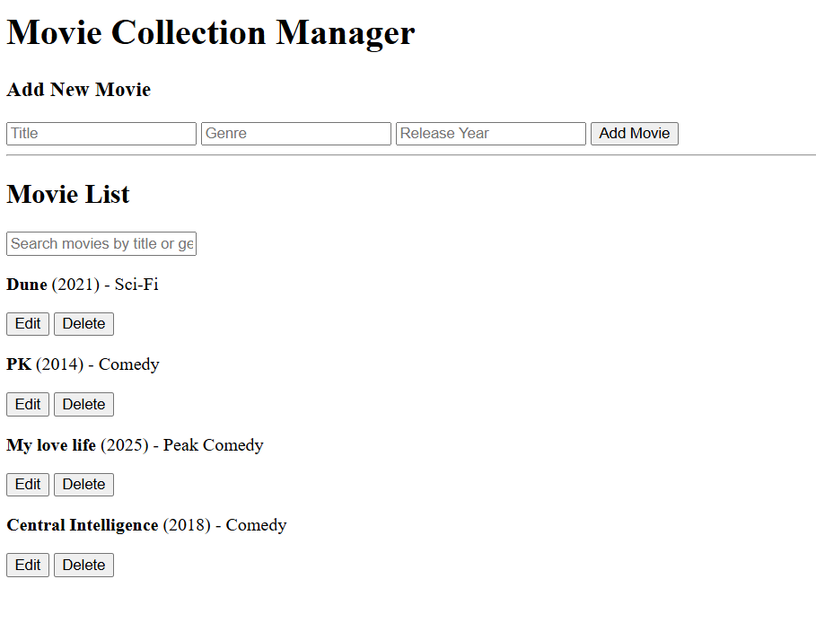

<!DOCTYPE html>
<html lang="en">
<head>
<meta charset="UTF-8">
<title>Movie Manager</title>
</head>
<body>
<h1>Movie Collection Manager</h1>
<form id="add-movie-form">
<h3>Add New Movie</h3>
<input type="text" id="title" placeholder="Title" required>
<input type="text" id="genre" placeholder="Genre">
<input type="number" id="year" placeholder="Release Year" required>
<button type="submit">Add Movie</button>
</form>
<hr>
<h2>Movie List</h2>
<input type="text" id="search-input" placeholder="Search movies by title or genre">
<div id="movie-list">
</div>
<script src="script.js"></script>
</body>
</html>

const API_URL = 'http://localhost:3000/movies';
const movieListDiv = document.getElementById('movie-list');
const searchInput = document.getElementById('search-input');
const form = document.getElementById('add-movie-form');
let allMovies = []; // Stores the full, unfiltered list of movies
// Function to dynamically render movies to the HTML
function renderMovies(moviesToDisplay) {
movieListDiv.innerHTML = '';
if (moviesToDisplay.length === 0) {
movieListDiv.innerHTML = '<p>No movies found matching your criteria.</p>';
return;
}
moviesToDisplay.forEach(movie => {
const movieElement = document.createElement('div');
movieElement.classList.add('movie-item');
movieElement.innerHTML = `
<p><strong>${movie.title}</strong> (${movie.year}) - ${movie.genre}</p>
<button onclick="editMoviePrompt(${movie.id}, '${movie.title}', ${movie.year},
'${movie.genre}')">Edit</button>
<button onclick="deleteMovie(${movie.id})">Delete</button>
`;
movieListDiv.appendChild(movieElement);
});
}
// Function to fetch all movies and store them (READ)
function fetchMovies() {
fetch(API_URL)
.then(response => response.json())
.then(movies => {
allMovies = movies; // Store the full list
renderMovies(allMovies); // Display the full list
})
.catch(error => console.error('Error fetching movies:', error));
}
fetchMovies(); // Initial load

searchInput.addEventListener('input', function() {
const searchTerm = searchInput.value.toLowerCase();
// Filter the global 'allMovies' array based on title or genre match
const filteredMovies = allMovies.filter(movie => {
const titleMatch = movie.title.toLowerCase().includes(searchTerm);
const genreMatch = movie.genre.toLowerCase().includes(searchTerm);
return titleMatch || genreMatch;
});
renderMovies(filteredMovies); // Display the filtered results
});

form.addEventListener('submit', function(event) {
event.preventDefault();
const newMovie = {
title: document.getElementById('title').value,
genre: document.getElementById('genre').value,
year: parseInt(document.getElementById('year').value)
};
fetch(API_URL, {
method: 'POST',
headers: { 'Content-Type': 'application/json' },
body: JSON.stringify(newMovie),
})
.then(response => {
if (!response.ok) throw new Error('Failed to add movie');
return response.json();
})
.then(() => {
this.reset();
fetchMovies(); // Refresh the list
})
.catch(error => console.error('Error adding movie:', error));
});

// Function to collect new data
function editMoviePrompt(id, currentTitle, currentYear, currentGenre) {
const newTitle = prompt('Enter new Title:', currentTitle);
const newYearStr = prompt('Enter new Year:', currentYear);
const newGenre = prompt('Enter new Genre:', currentGenre);
if (newTitle && newYearStr && newGenre) {
const updatedMovie = {
id: id,
title: newTitle,
year: parseInt(newYearStr),
genre: newGenre
};
updateMovie(id, updatedMovie);
}
}

// Function to send PUT request
function updateMovie(movieId, updatedMovieData) {
fetch(`${API_URL}/${movieId}`, { // Target the specific resource by ID
method: 'PUT',
headers: { 'Content-Type': 'application/json' },
body: JSON.stringify(updatedMovieData),
})
.then(response => {
if (!response.ok) throw new Error('Failed to update movie');
return response.json();
})
.then(() => {
fetchMovies(); // Refresh list
})
.catch(error => console.error('Error updating movie:', error));
}

function deleteMovie(movieId) {
fetch(`${API_URL}/${movieId}`, { // Target the specific resource by ID
method: 'DELETE',
})
.then(response => {
if (!response.ok) throw new Error('Failed to delete movie');
fetchMovies(); // Refresh list
})
.catch(error => console.error('Error deleting movie:', error));
}

